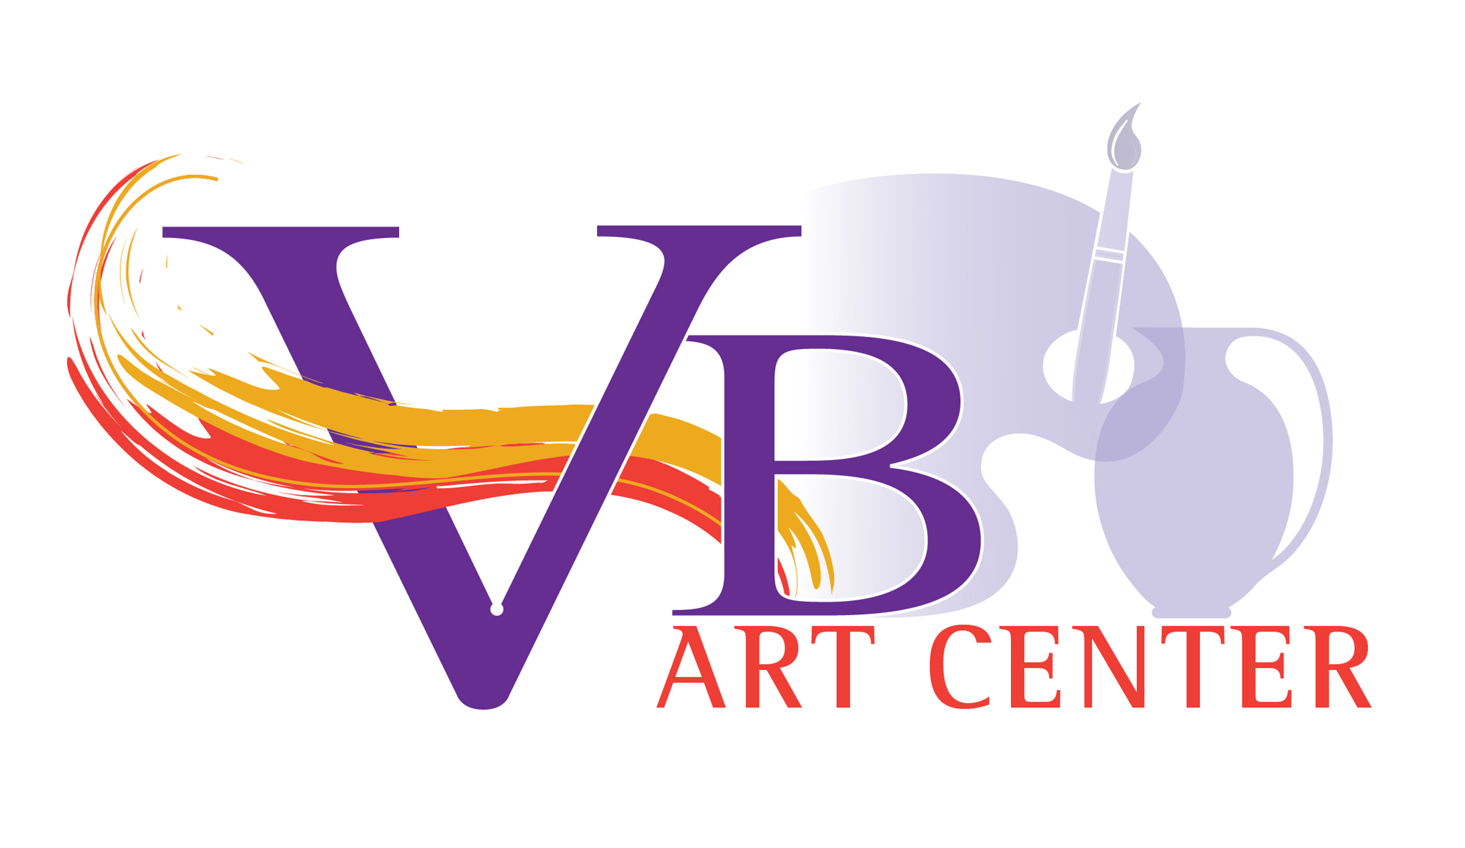
Class Proposal Form

Please complete this form for each class that you are proposing to teach at the VB Art Center. You can certainly take as much space as you need. The blue-type can be removed. It is there for your reference only.

Class Name: Please provide a suggested class title. It may include your name if desired. Think of something catchy that everyone will want to take!
Instructor Name: Your Name
Instructor Phone: Your Phone
Instructor Email: Your Email
Instructor Address: Your Mailing Address
Location to Teach: Virginia Beach Art Center, Online, Other Location
Other location: Indicate other location and why the class is better suited at another location
Start Date: Indicate the Date you would be available to start classes. This Start Date will be adjusted in the registration system once the proposal has been accepted to move forward to teach.
End Date: Indicate the Date you would need to end a class.
Day(s) of the Week: Indicate the day or days of the week that the class will take place. If you are flexible, indicate the Days of the week of flexibility and morning/afternoon/evening preference to allow Art Class Manager & Pottery Manager to fit proposal into the schedule.
Start Time: Time the class is proposed to begin. (For advertising and scheduling).
End Time: Time the class is proposed to end. (For advertising and scheduling)
Class Description:
Please provide a description of your proposed Curriculum.
Pottery Example:
Objectives – The outcomes a student will walk away from your class with:
- Demonstrate the pinch and pull method
- Demonstrate the coil, slip, and score method using clay
- Demonstrate the slab method in clay
- Demonstrate the additive and subtractive methods using clay to create a 3D object
- Demonstrate glazing techniques
Activities/Class Plan – The items you will cover in each meeting date. (Example is for an eight week pottery class – feel free to adjust in accordance with the intentions of your class proposal.)
Class 1 – Create a pinch pot, Create a pinch pot with stamping and a lid, Create a pinch pot with feet, Create a pinch pot with a decorative lip.
Class 2 – Create a pot using the coil method with a variety of coils.
Class 3 – Create a container using the slab method using scoring and slip and creating texture (relief and/or incised), Create a slump pot draped over a balloon or container, Create a mobile or wind chime using the slab technique.
Class 4 – Create a fun object using the additive/subtractive method (Pop Art, mugs, faces, masks, vessel/combo pot, Picasso head, birdhouse, teapot) May use: pinch, pull, coil, slab, slip, and score.
Class 5 – Create a box with a lid from slabs of clay.
Class 6 – Create a slab mug from an Instructor-provided template.
Class 7 – Finish works leading to final bisque firing week and demonstrate glazing methods.
Class 8 – Finish glazing works to be fired.
Instructor Style: – Please describe your approach, philosophy, and style of teaching. For example: Do you typically demonstrate something and leave students to go and work on their pieces? Do you demonstrate and then make yourself available providing input along the way as students work through the class objectives? Do you have a demonstration option available at each class but you are not offended if students choose to work on their own? Do you keep track of the students work to provide input as to covering/drying towards success?
  - Supply list: (when student needs to bring supplies): Brushes, paints, canvas, sketch pad etc. *Note: for Pottery Studio 8-week classes, it is the intention of VB ART Center to include 25# of clay, studio firing of up to 10 pieces within dimensional limits and use of studio glazes. If you will ask students to bring a different type of clay or other materials, please indicate that here.
  - Supplies included: Will you be including special supplies in the cost of the class
Skill Level: What is the entry skill-level you anticipate your students to have coming into your class. Are you open to all skill levels and the challenges that might come with both beginner, intermediate, and expert level students all in the same class – can you accommodate the needs of all at the same time?
Number of Classes:
Website: Provide your website if available for students to see the style of work you make. In advertising VB Art Center may refer to your website as well as provide the website to sign-up for classes.
Age restriction: Are there any age restrictions for the attendees in your class?
Class Limit: How many students will be maximum for your class? Note: If you are proposing more than 10 to start please provide an explanation as to how you will accommodate all students (for example will you provide or do you need a studio assistant?)

Images: Please include a .jpeg image or images of the type of artwork that you are planning on teaching and/or a picture of you teaching.

A completed W-9 Form, Instructor Information Form, VB Art Center Instructor Contract, Signed Pottery Policies Handbook Acknowledgement (for potters), and New Instructor Training are required before classes begin.

Minimum class size is approximately 5 students. Class will be cancelled by VB Art Center if minimum is not met.

Instructor compensation can be discussed with the Pottery Manager or Art Class Manager.

Instructor Signature: ________________________________ Date: ____________________

VB Art Center Signature: _______________________________ Date: ____________________

Office Use:
__In Active as Instructor
__Class added to Active

